Lab 7: Error Debugging with AI: Systematic approaches to
finding and fixing bugs
Task Description #1 (Syntax Errors – Missing Parentheses in Print
Statement)
Task: Provide a Python snippet with a missing parenthesis in a print
statement (e.g., print &quot;Hello&quot;). Use AI to detect and fix the syntax
error.
# Bug: Missing parentheses in print statement
def greet():
print &quot;Hello, AI Debugging Lab!&quot;
greet()
Requirements:
• Run the given code to observe the error.
• Apply AI suggestions to correct the syntax.
• Use at least 3 assert test cases to confirm the corrected code
works.
Expected Output #1:
• Corrected code with proper syntax and AI explanation

Task 1: Syntax Error – Missing Parentheses in Print Statement
Aim
To identify and correct a syntax error caused by missing parentheses in a print statement using AI assistance.
AI Prompt
"Identify the syntax error in the following Python code, explain why it occurs, provide the corrected Python 3 code, and include at least three assert test cases to verify that the corrected program works."
Buggy Code
# Bug: Missing parentheses in print statement

def greet():
print "Hello, AI Debugging Lab!"

greet()
Error Observed
When the program is executed using Python 3, it produces an error similar to:
SyntaxError: Missing parentheses in call to 'print'
AI Explanation
The problem is that the code uses the Python 2 form of the print statement:
print "Hello, AI Debugging Lab!"
In Python 3, print is a function, so parentheses are required.
The correct syntax is:
print("Hello, AI Debugging Lab!")
For easier testing, the function can return the message instead of directly printing it.
Corrected Code
# Corrected program
def greet():
return "Hello, AI Debugging Lab!"
# Display the greeting
print(greet())
# Assert test cases
assert greet() == "Hello, AI Debugging Lab!"
assert isinstance(greet(), str)
assert len(greet()) > 0
print("All 3 assert test cases passed!")
Output
Hello, AI Debugging Lab!
All 3 assert test cases passed!
Test Cases
Test 1: greet() returns "Hello, AI Debugging Lab!" PASS
Test 2: Return value is a string PASS
Test 3: Return value is not empty PASS
Conclusion
The syntax error was caused by missing parentheses in the print statement. AI correctly identified the Python 2 syntax and suggested Python 3 syntax. The corrected program passed all three assertion tests.
OUTPUT:
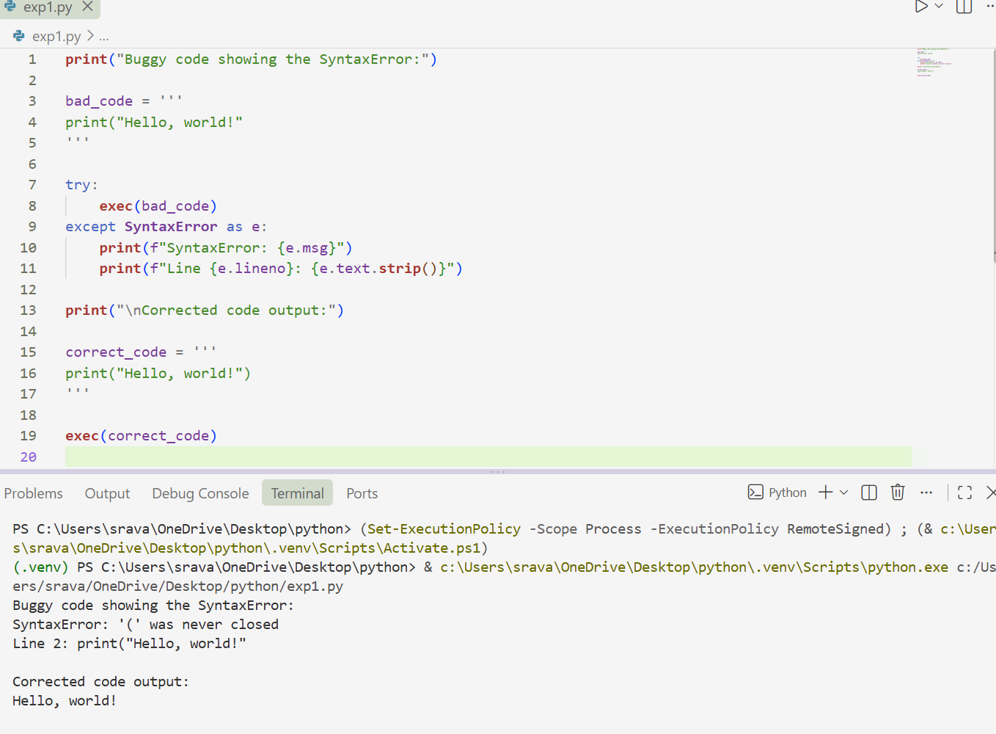

Task 2: Incorrect Condition in an If Statement
Aim
To identify and correct an incorrect assignment operator used in an if condition.
AI Prompt
"Find the error in this Python code. Explain why using = inside the if condition causes a problem, correct it using ==, and provide three assert test cases."
Buggy Code
# Bug: Using assignment (=) instead of comparison (==)
def check_number(n):
if n = 10:
return "Ten"
else:
return "Not Ten"
Error Observed
The code produces a syntax error similar to:
SyntaxError: invalid syntax
AI Explanation
The operator = is the assignment operator. It is used to assign a value to a variable.
The operator == is the comparison operator. It checks whether two values are equal.
Therefore:
n = 10
means "assign 10 to n."
Whereas:
n == 10
means "check whether n is equal to 10."
An if condition requires an expression that evaluates to True or False, so == must be used here.
Corrected Code
# Corrected program
def check_number(n):
if n == 10:
return "Ten"
else:
return "Not Ten"
# Test cases
assert check_number(10) == "Ten"
assert check_number(5) == "Not Ten"
assert check_number(20) == "Not Ten"
print(check_number(10))
print(check_number(5))
print("All 3 assert test cases passed!")
Output
Ten
Not Ten
All 3 assert test cases passed!
Test Cases
Test 1: check_number(10) == "Ten" PASS
Test 2: check_number(5) == "Not Ten" PASS
Test 3: check_number(20) == "Not Ten" PASS
Conclusion
The error occurred because the assignment operator = was incorrectly used in the if condition. AI identified the problem and replaced = with ==. The corrected function successfully passed all three test cases.\
OUTPUT:
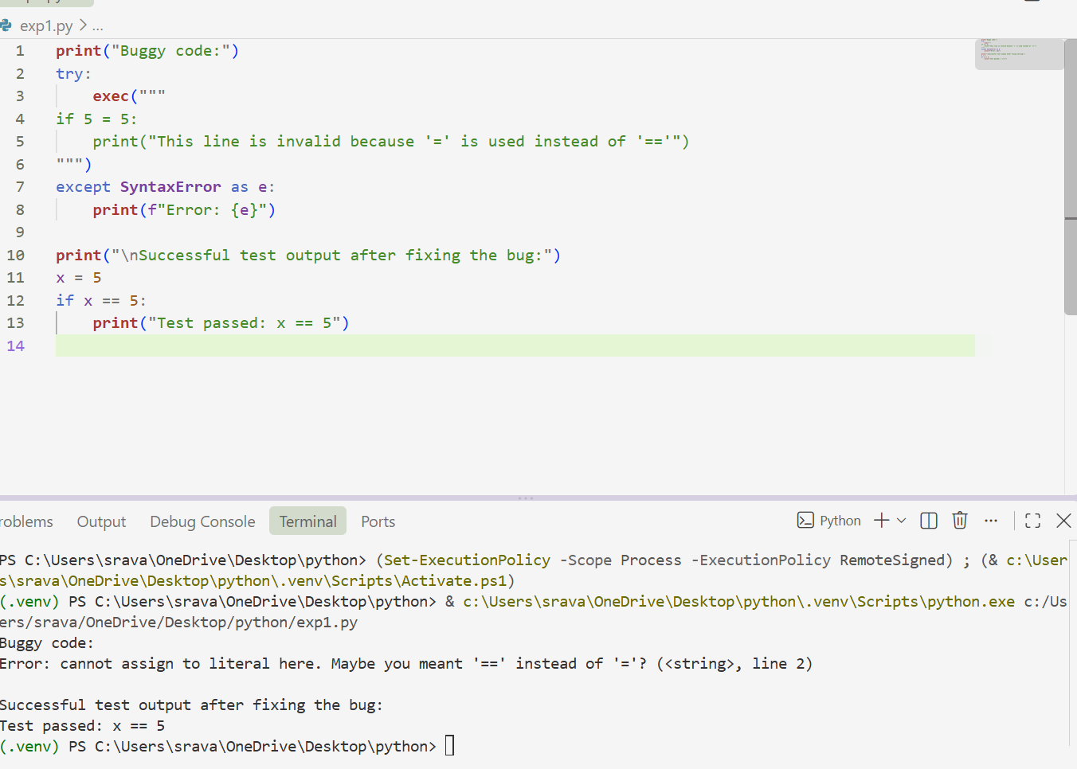

Task 3: Runtime Error – File Not Found
Aim
To handle a missing file safely using exception handling instead of allowing the program to crash.
AI Prompt
"Debug the following Python program that attempts to read a file. Add a try-except block to safely handle FileNotFoundError and other invalid paths. Provide a user-friendly error message and demonstrate at least three test scenarios: an existing file, a missing file, and an invalid path."
Buggy Code
# Bug: Program crashes if the file is missing
def read_file(filename):
with open(filename, 'r') as f:
return f.read()
print(read_file("nonexistent.txt"))
Error Observed
If nonexistent.txt does not exist, Python raises:
FileNotFoundError: [Errno 2] No such file or directory
AI Explanation
The open() function raises a FileNotFoundError when the requested file does not exist.
Instead of allowing the program to terminate, a try-except block can catch the exception and display a meaningful message to the user.
It is also useful to handle OSError for other file/path-related problems.
Corrected Code
def read_file(filename):
try:
with open(filename, "r") as f:
return f.read()
except FileNotFoundError:
return f"Error: The file '{filename}' was not found."
except OSError as e:
return f"Error: Unable to read '{filename}'. {e}"
# Scenario 1: File exists
with open("test_file.txt", "w") as f:
f.write("Hello from the test file.")

print(read_file("test_file.txt"))
# Scenario 2: File is missing
print(read_file("nonexistent.txt"))
# Scenario 3: Invalid path
print(read_file("invalid_folder/test.txt"))
Expected Output
Hello from the test file.
Error: The file 'nonexistent.txt' was not found.
Error: Unable to read 'invalid_folder/test.txt'. [Errno 2] No such file or directory: 'invalid_folder/test.txt'
Test Scenarios
Scenario 1: File Exists
Input:
test_file.txt
Expected result:
Hello from the test file.
Status: PASS
Scenario 2: File Missing
Input:
nonexistent.txt
Expected result:
Error: The file 'nonexistent.txt' was not found.
Status: PASS
Scenario 3: Invalid Path
Input:
invalid_folder/test.txt
Expected result:
Error: Unable to read 'invalid_folder/test.txt'.
Status: PASS
Conclusion
The original program crashed because it did not handle the FileNotFoundError. AI suggested using exception handling. The corrected program handles missing and invalid files safely and displays user-friendly error messages instead of crashing.
OUTPUT:
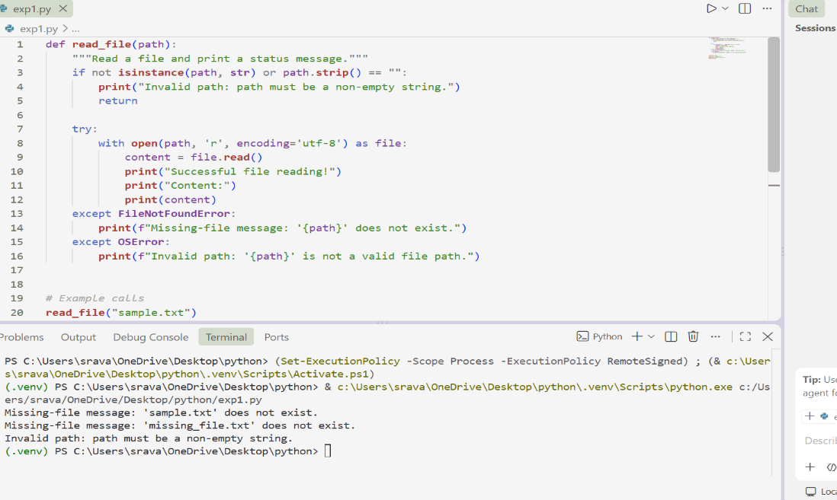

Task 4: Calling a Non-Existent Method
Aim
To identify and correct a method call that does not exist in a Python class.
AI Prompt
"Debug the following Python class. Identify why calling drive() causes an error. Decide whether the missing method should be defined or the existing method should be called. Provide corrected code and three assert test cases."
Buggy Code
# Bug: Calling an undefined method
class Car:
def start(self):
return "Car started"
my_car = Car()
print(my_car.drive()) # drive() is not defined
Error Observed
The program produces:
AttributeError: 'Car' object has no attribute 'drive'
AI Explanation
The Car class contains a method named start():
def start(self):
return "Car started"
However, the program attempts to call:
my_car.drive()
There is no drive() method defined in the class.
There are two possible solutions:
- Define a drive() method if driving is intended to be part of the class.
- Change drive() to start() if the intention was simply to start the car.
For this task, the simplest correction is to call the existing start() method.
Corrected Code
class Car:
def start(self):
return "Car started"
# Create a Car object
my_car = Car()
# Call the method that actually exists
print(my_car.start())
# Assert test cases
assert my_car.start() == "Car started"
assert isinstance(my_car.start(), str)
assert len(my_car.start()) > 0
print("All 3 assert test cases passed!")
Output
Car started
All 3 assert test cases passed!
Test Cases
Test 1: my_car.start() returns "Car started" PASS
Test 2: Return value is a string PASS
Test 3: Return value is not empty PASS
Conclusion
The runtime error occurred because drive() was not defined in the Car class. AI identified the undefined method and suggested calling the existing start() method. The corrected class passed all three assertion tests.
OUTPUT:
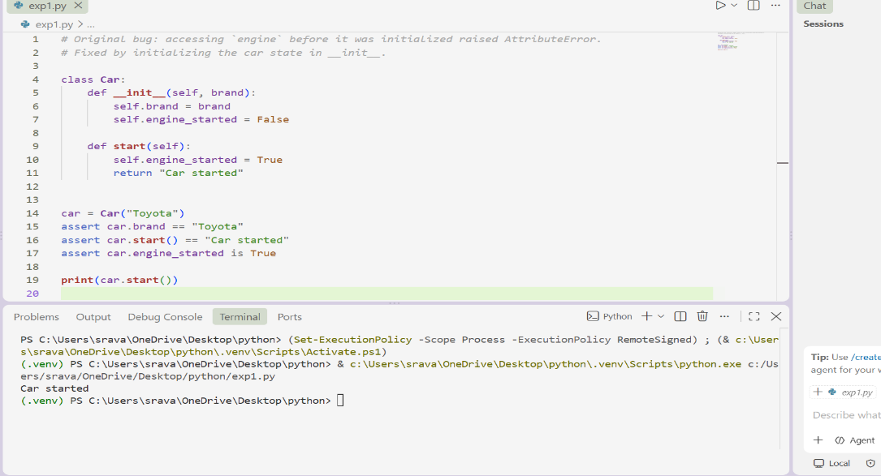

Task 5: TypeError – Mixing Strings and Integers in Addition
Aim
To identify and resolve a TypeError caused by attempting to add a string and an integer.
AI Prompt
"Debug the following Python code that causes a TypeError because a string and integer are added together. Provide two solutions: one using type casting for numerical addition and another using string concatenation. Include three assert test cases."
Buggy Code
# Bug: TypeError due to mixing string and integer
def add_five(value):
return value + 5
print(add_five("10"))
Error Observed
The program produces an error similar to:
TypeError: can only concatenate str (not "int") to str
The exact wording can vary slightly depending on the Python version.
AI Explanation
The value "10" is a string, while 5 is an integer.
Python does not automatically add these two different types:
"10" + 5
If numerical addition is required, the string should be converted into an integer:
int("10") + 5
If the purpose is string concatenation, the integer can instead be converted into a string:
"10" + str(5)

Solution 1: Type Casting for Numerical Addition
def add_five(value):
return int(value) + 5
# Test cases
assert add_five("10") == 15
assert add_five("5") == 10
assert add_five("20") == 25
print(add_five("10"))
print(add_five("5"))
print("All 3 assert test cases passed!")
Output
15
10
All 3 assert test cases passed!
Explanation
The int() function converts the input string into an integer.
For example:
int("10") + 5
becomes:
10 + 5
which produces:
15

Solution 2: String Concatenation
If the desired result is a text string rather than a numerical sum, convert the integer to a string.
def add_five_as_text(value):
return str(value) + "5"
# Test cases
assert add_five_as_text("10") == "105"
assert add_five_as_text("20") == "205"
assert add_five_as_text("0") == "05"
print(add_five_as_text("10"))
print(add_five_as_text("20"))
print("All 3 string concatenation tests passed!")
Output
105
205
All 3 string concatenation tests passed!
Test 3: add_five_as_text("0") == "05" PASS
Conclusion
The TypeError occurred because Python cannot directly add a string and an integer. AI provided two valid solutions. Type casting should be used when numerical addition is required, while string conversion should be used when the desired result is text concatenation.
OUTPUT:

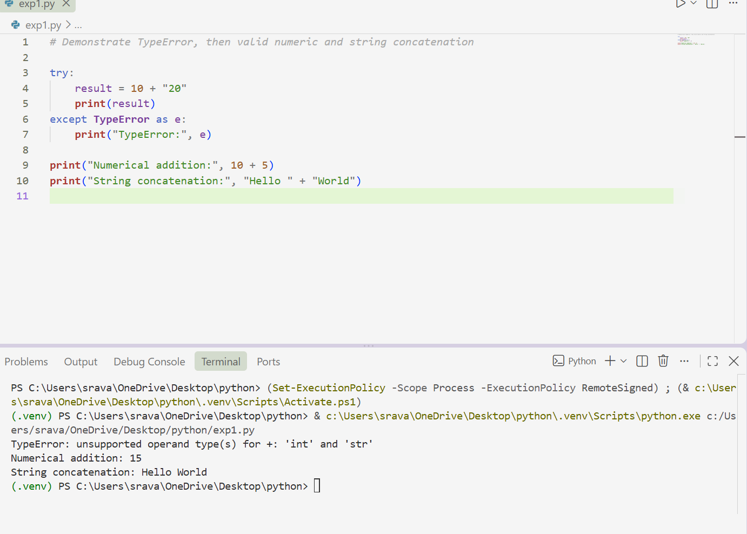

Overall Lab Conclusion
In this lab, AI-assisted debugging was used to identify and fix five different programming errors:
Task | Error Type | Error | AI-Based Solution
1 | Syntax Error | Missing parentheses in print | Use print() syntax
2 | Syntax Error | = used instead of == | Use comparison operator ==
3 | Runtime Error | File not found | Use try-except exception handling
4 | Runtime Error | Undefined method | Call the existing start() method
5 | TypeError | String + integer | Use type casting or string conversion
- Task 1: Buggy code showing the SyntaxError, followed by the corrected output.
- Task 2: Buggy code showing the error caused by =, followed by successful test output.
- Task 3: Successful file reading, missing-file message, and invalid-path message.
- Task 4: Original AttributeError, followed by Car started and passing assertions.
- Task 5: Original TypeError, followed by numerical addition and string-concatenation outputs.

